**Networking:**

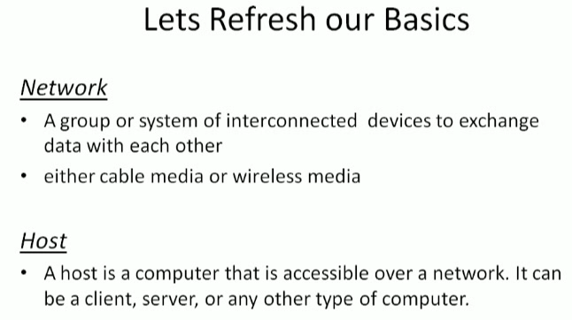

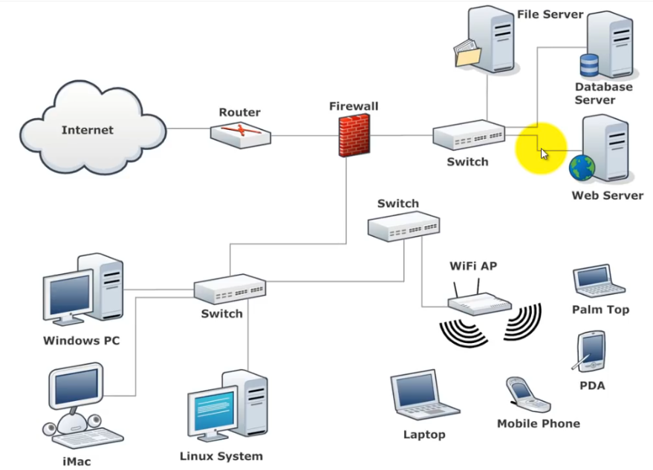

* Connection between a computer to computer with RJ45 cable or anything is called ethernet
* The network inside the organisation or something available locally is called LAN (Local Area Network)

**Difference between LAN, MAN & WAN:**

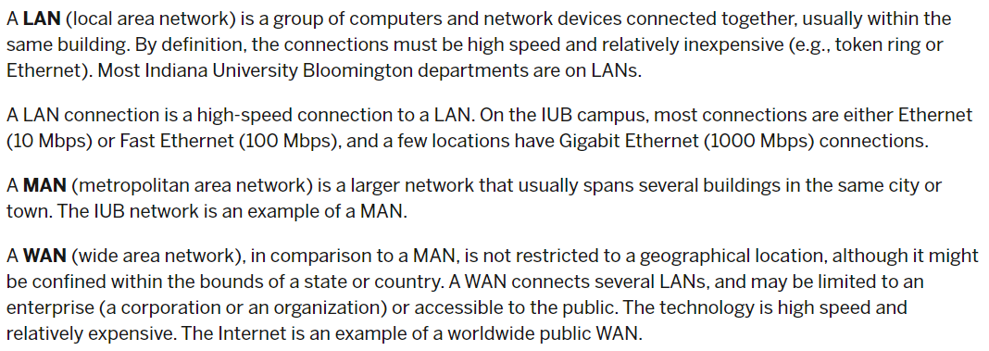

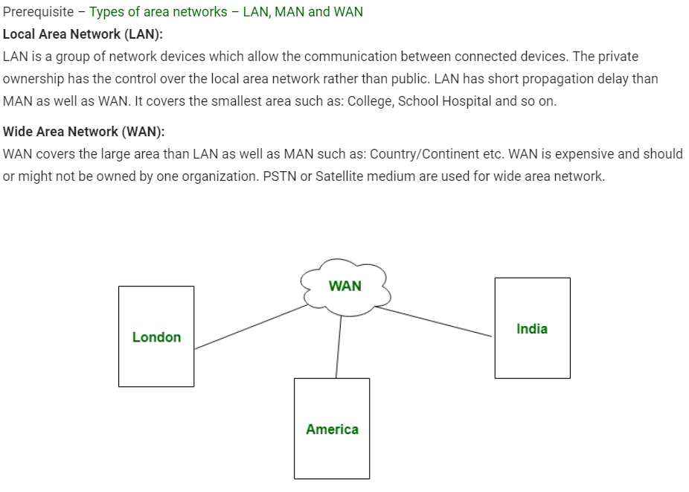

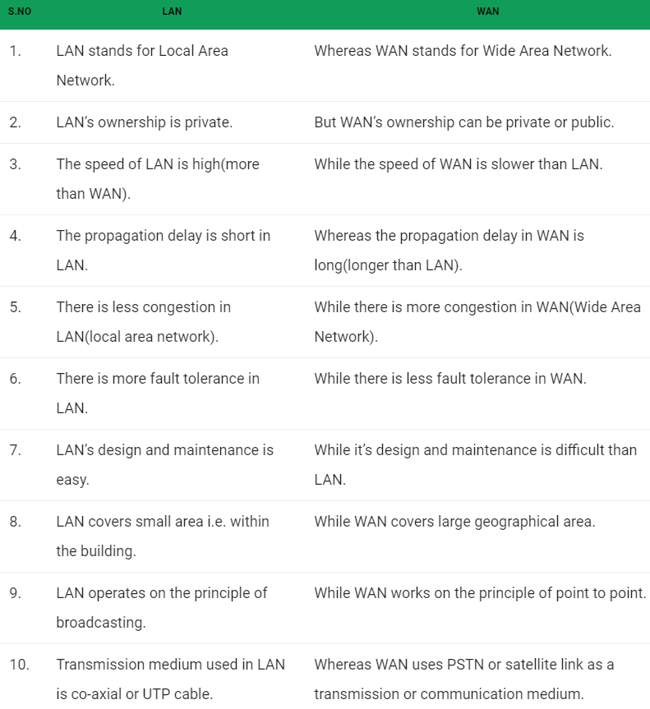

**Internet vs intranet:**

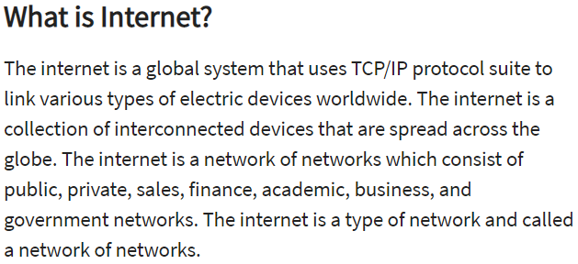

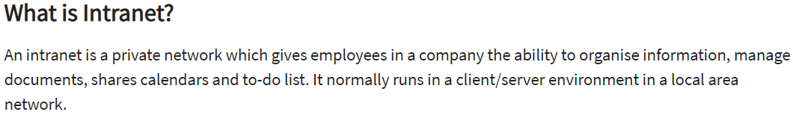

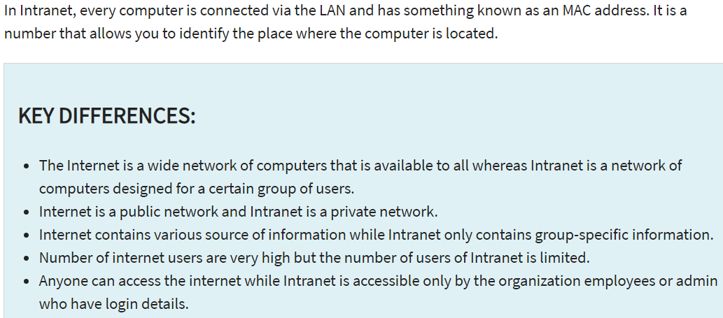

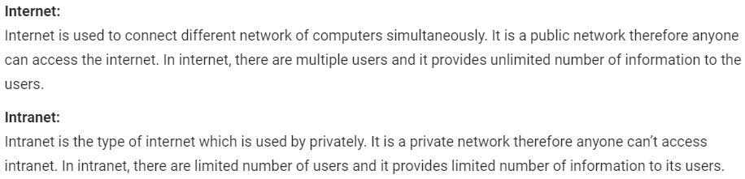

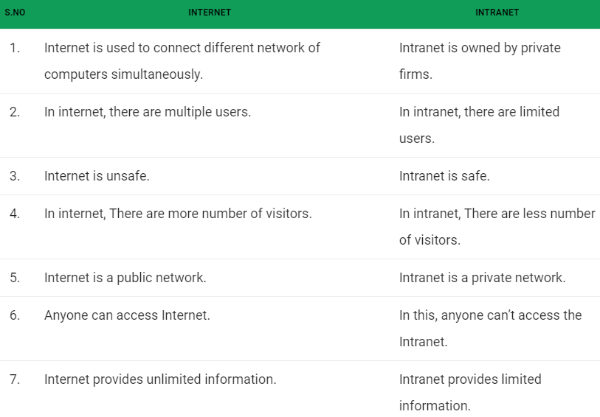

**Difference between LAN and Intranet:**

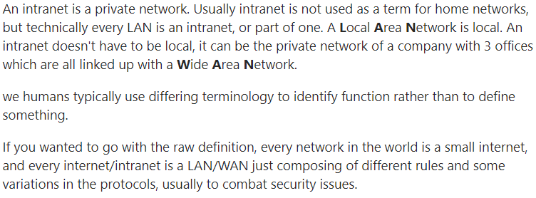

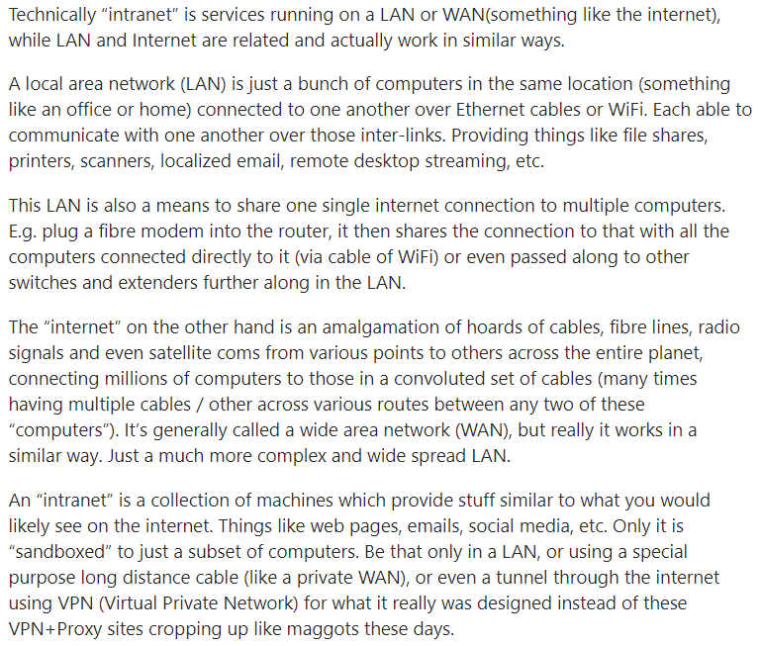

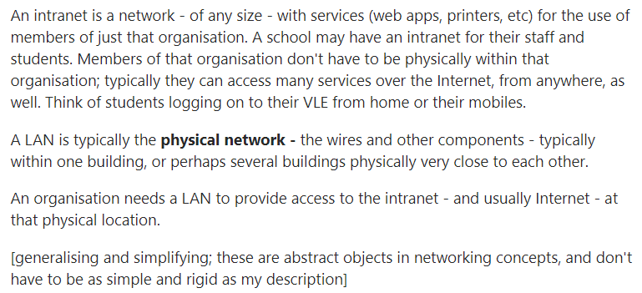

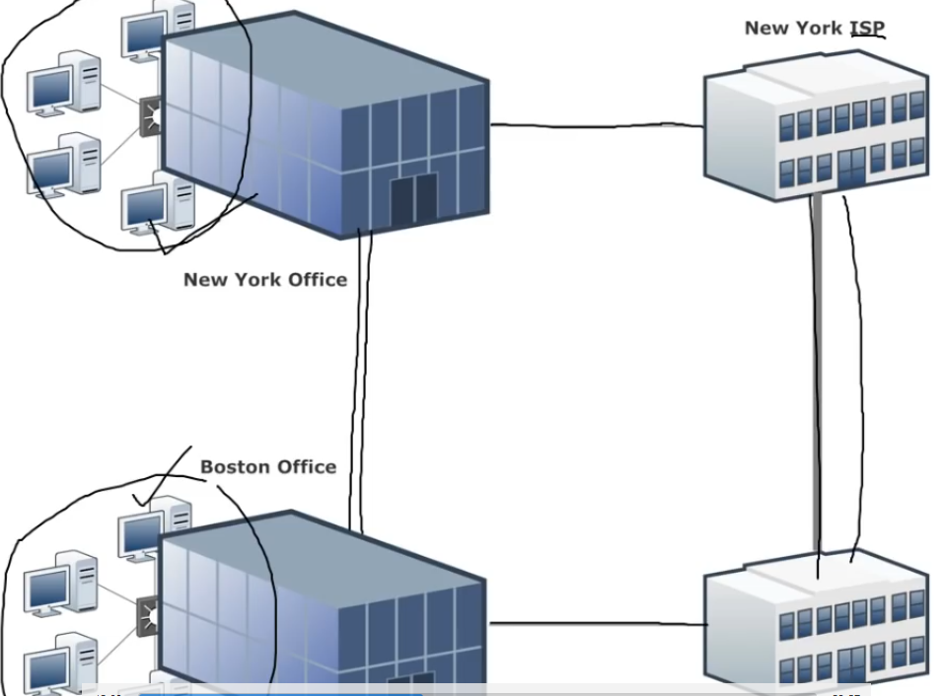

* As above, the ISPs has connection with each other anyways. So, both the companies can communicate with each other via ISP
* This forms WAN where LANs connected each other to form WAN (Wide Area Network)
* Internet is massive WAN connected to the world. It is just interconnection between lot of WANs



* If we want to connect to a domain in another network. We use domain name; it has to convert into IP address
* There is a service to convert domain into IP
* Why IP address is because it has two parts. One part is called network id which used to connect the other network, and another is host id which is used to reach the host inside network
* And to reach the process, we need port

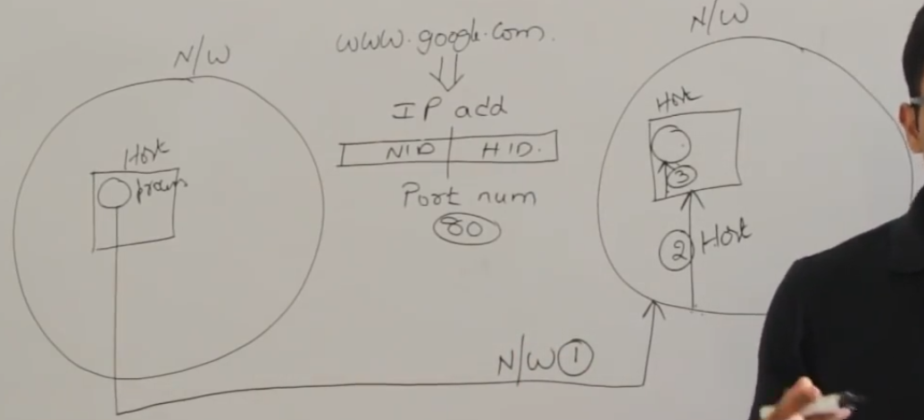

* For web servicers, by default it is 80 port
* Our internet service providers should provide service called DNS (Domain Name Server) inside the network
* So, here before contacting the google, we first check the ip of site with DNS and the DNS will return the ip to the process
* This is called DNS overhead
* So, sometimes when we contact a server, it might take some time as there will be DNS overhead, but from second time it will be direct contact
* The main important thing in this communication is IP address

**Packets:**

